PRE-CAlcULUS 12
Review Questions
for
Final Exam

LG 17
take-home package

Frances Kelsey Secondary School – 2019/20

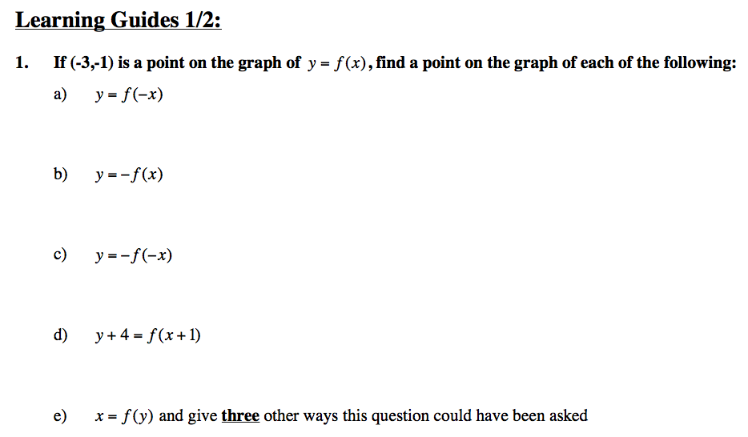

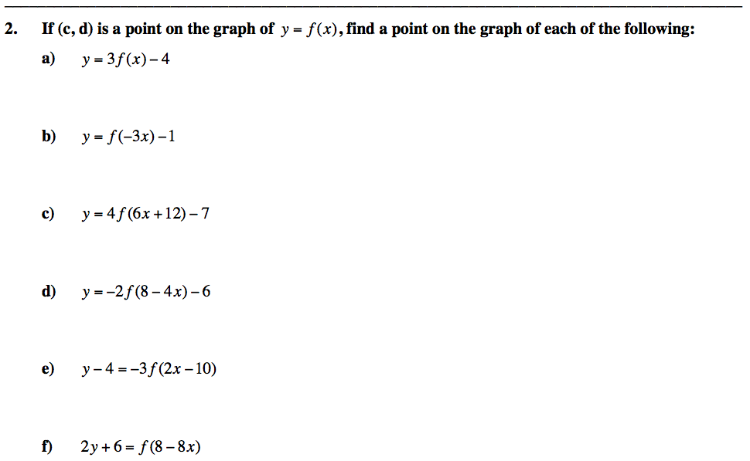

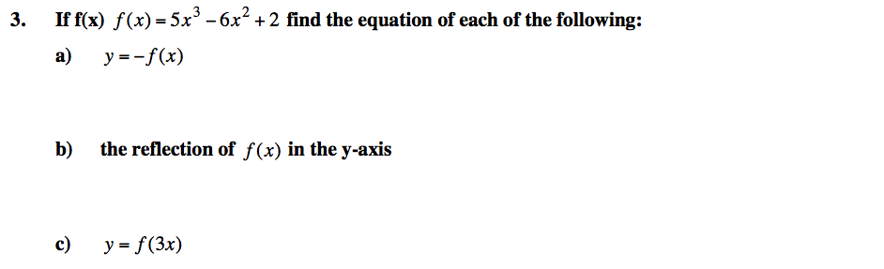

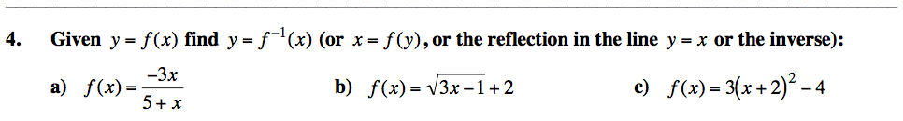

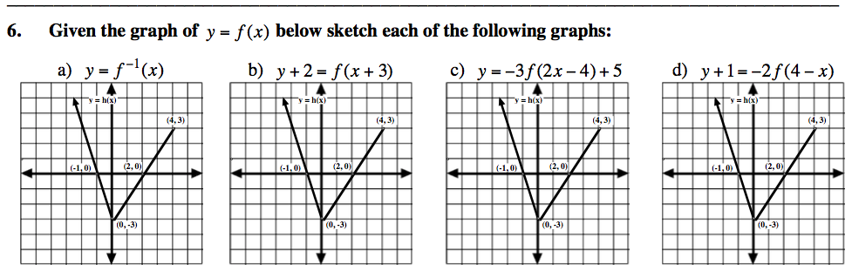

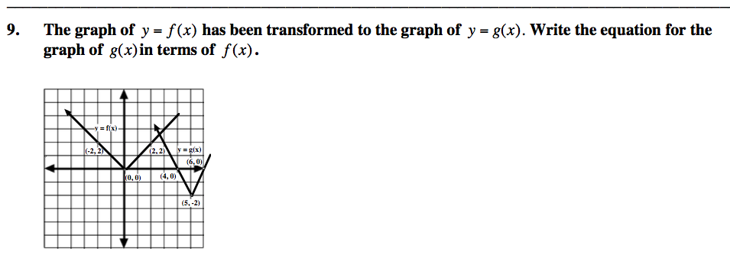

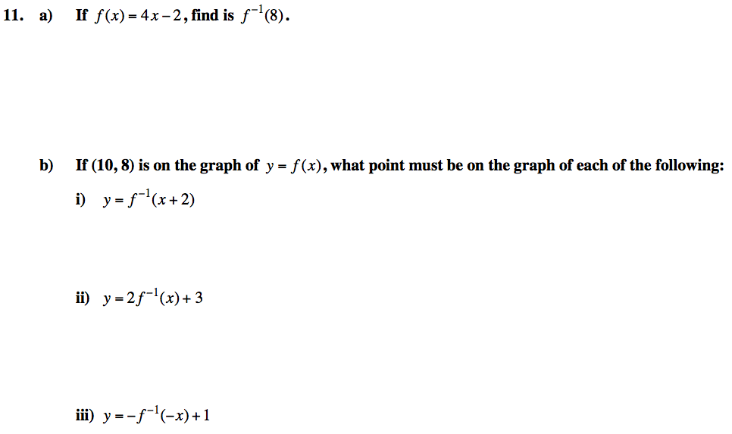

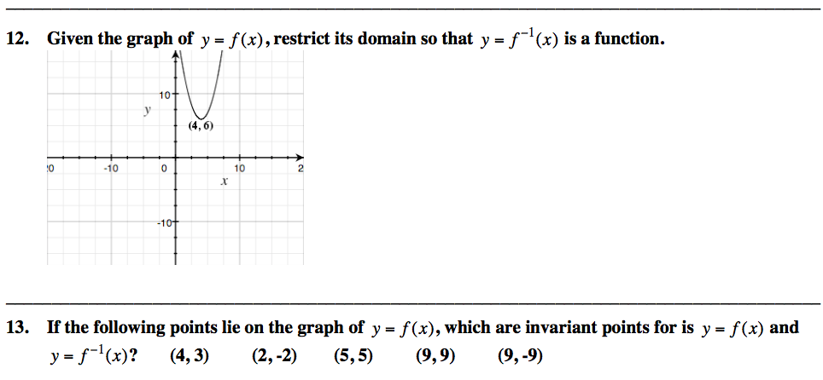

Learning Guide 3

1. Match each function to its corresponding graph.
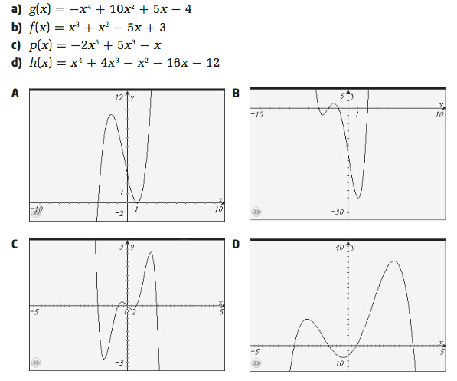_______________________________________________________________________________

2.
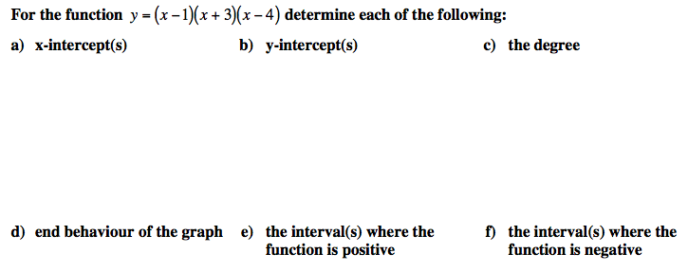
3. Use synthetic division to determine the remainder for $x^{3}+7x^{2}+3x+4 ÷ x+2$.

_______________________________________________________________________________

4. Use the remainder theorem to determine the remainder when $P\left(x\right)=x^{3}-10x+6$
is divided by $x+4.$

_______________________________________________________________________________

5. Determine the value of k if the remainder is 3 for $\left(kx^{3}+3x+1\right)÷\left(x+2\right).$

_______________________________________________________________________________

6 a)

_______________________________________________________________________________

6 b)

_______________________________________________________________________________

7.
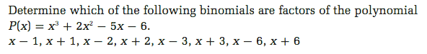

8.

9. Factor fully $x^{3}-4x^{2}-11x+30$.

_______________________________________________________________________________

10a) Determine the equation of the function shown on the graph below.

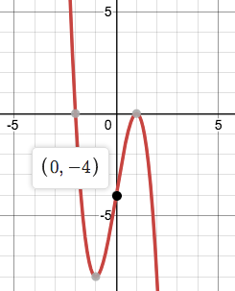
10b)
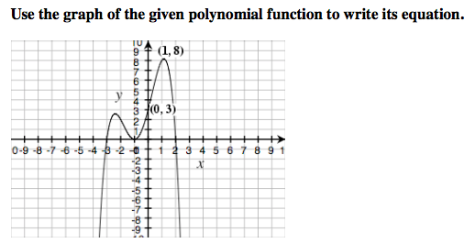

11. Determine the equation of the function that the zeros are -2, -1, and 3 (multiplicity 2)
and passes through the point (2, 24).

_______________________________________________________________________________

12.

_______________________________________________________________________________

13.
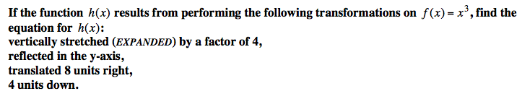
_______________________________________________________________________________

14.
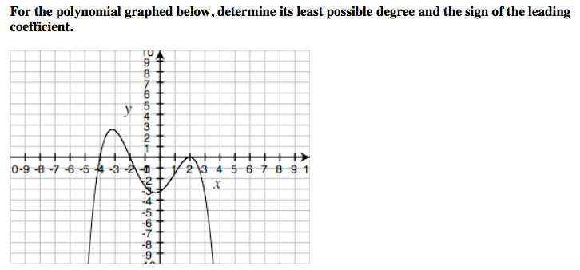

Learning Guide 4/5

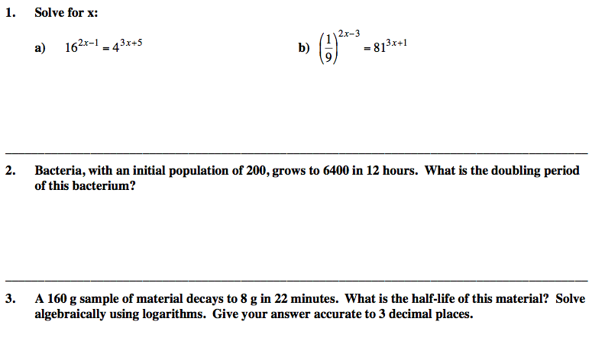

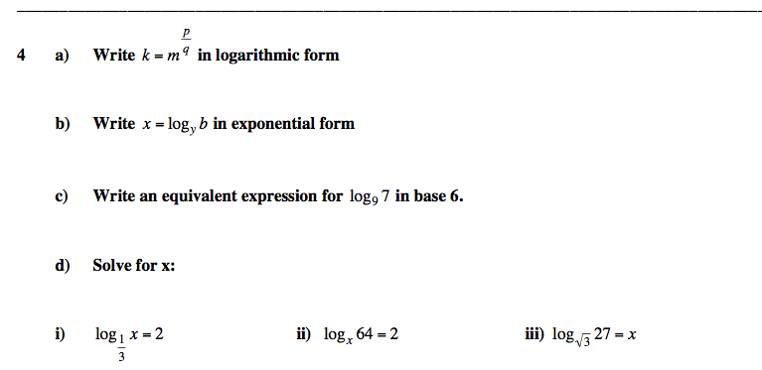

iv) $5^{2x}-6{\left(5\right)}^{x}+5=0$ v) $2^{x}+2^{x-3}=18$

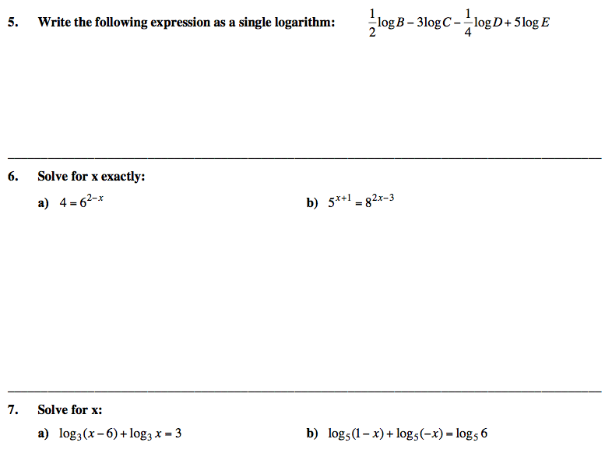

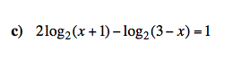

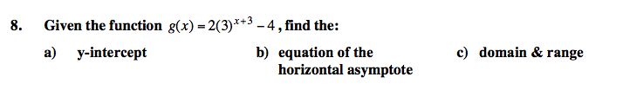

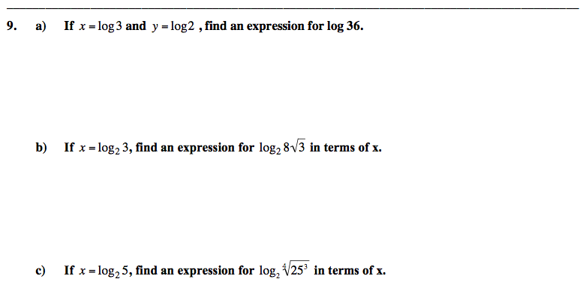

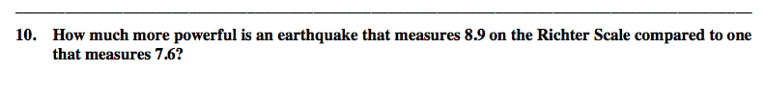

_______________________________________________________________________________

11. A 200 g sample of radioactive polonium-210 has a half-life of 138 days.
a) Determine an equation to model this situation of the mass of polonium that remains
after t days.

b) Determine the mass that remains after 5 years?

c) How long will it take for this 200 g sample to decay to 12.5 g?

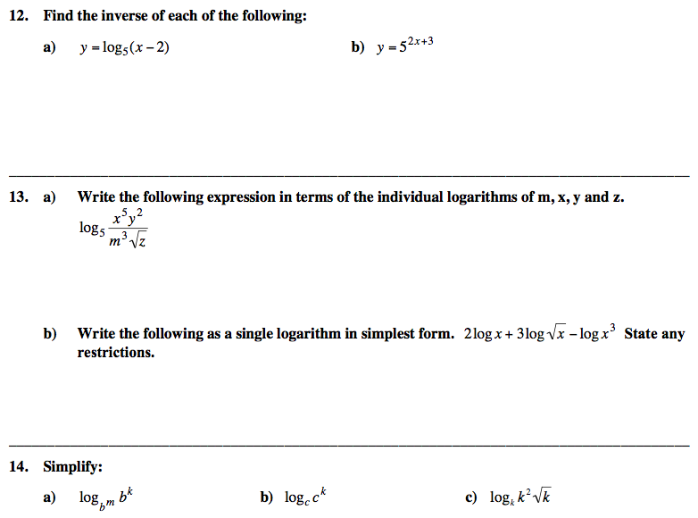

Learning Guide 6

1. Find the sum of the geometric series.

a) $S_{7} of 4+8+16+32+…$ b) $S_{∞} of 1-6+36-216+…$

c) $\frac{3}{25}+ ___+___+___+___+375$ d) $S_{6}=____$ given $t_{2}=1$ and $t_{5}=\frac{-1}{27}$

_______________________________________________________________________________

2. A geometric series has a sum of 1365. Each term increases by a factor of 4. If there are 6 terms,
find the value of the first term.

_______________________________________________________________________________

3. Rewrite each series as a sum.
a) b)
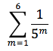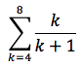

_______________________________________________________________________________

4. Evaluate each series.
a) b)
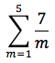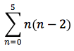

_______________________________________________________________________________

5. Rewrite each series using sigma notation.
a) $4+2+1+\frac{1}{2}+\frac{1}{4}+\frac{1}{8}$ b) $0+3+6+9$

c) $\frac{1}{2}+\frac{2}{3}+\frac{3}{4}+\frac{4}{5}+\frac{5}{6}$ d) $\frac{1}{5}+\frac{1}{3}+1-1$

Learning Guide 7/8

1.
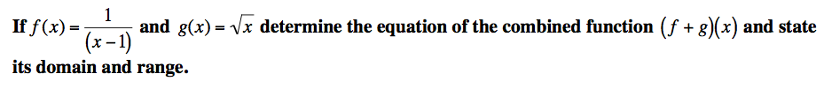

_______________________________________________________________________________

2.
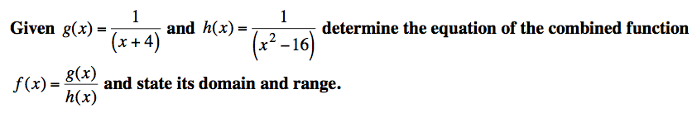

_______________________________________________________________________________

3.
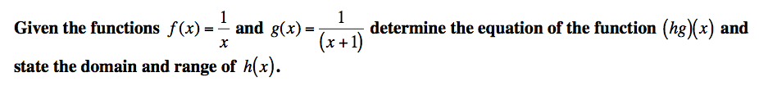

______________________________________________________________________________

4.
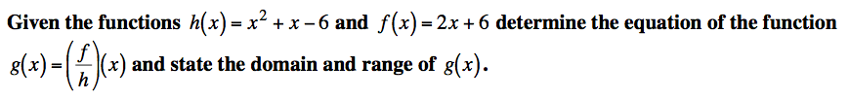

5.
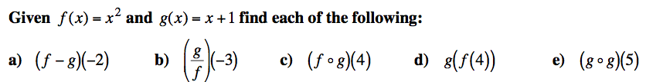

_______________________________________________________________________________

6.

_______________________________________________________________________________

7.
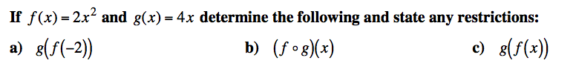

_______________________________________________________________________________

8.
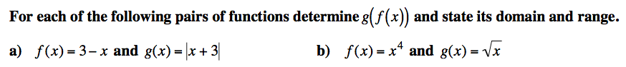

9.
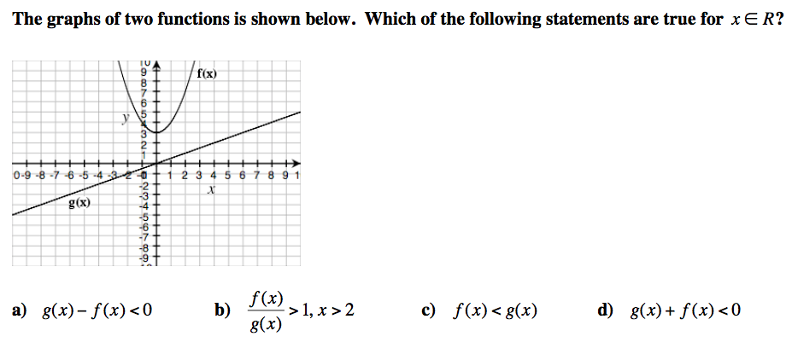

Learning Guide 10/11
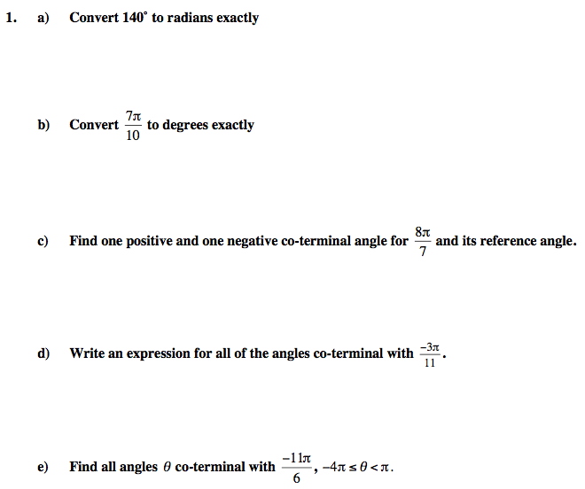

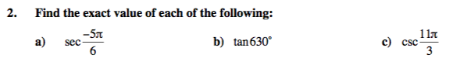

_______________________________________________________________________________
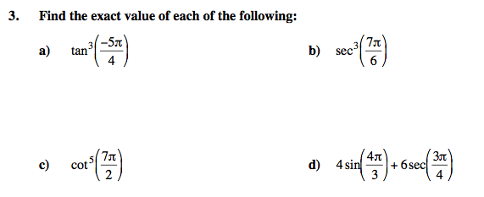

_______________________________________________________________________________
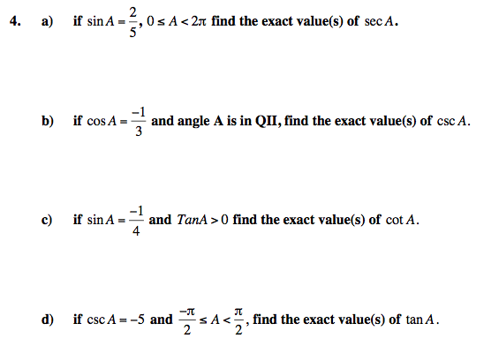

_______________________________________________________________________________

Learning Guide 12/13
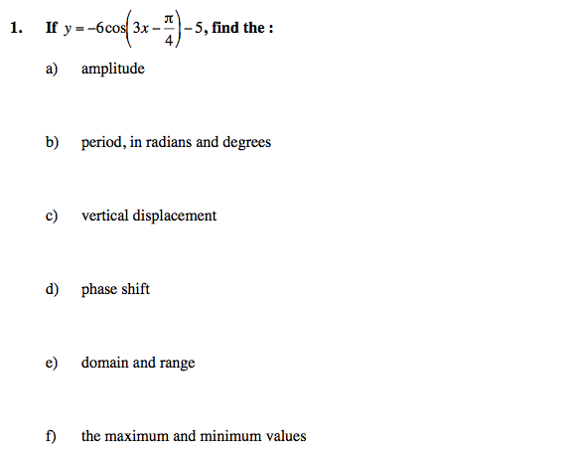

_______________________________________________________________________________
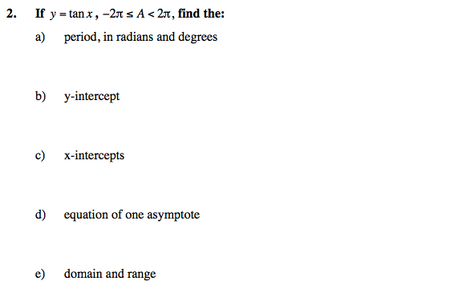

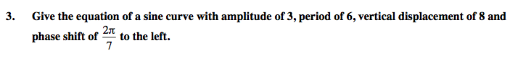

_______________________________________________________________________________
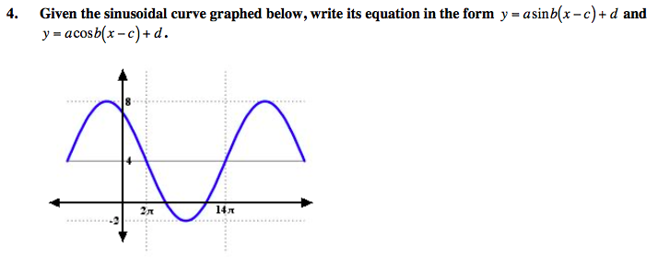
_______________________________________________________________________________

5. Graph $y=2sin\left(\frac{π}{3}x-\frac{π}{3}\right)-1$ for two cycles.
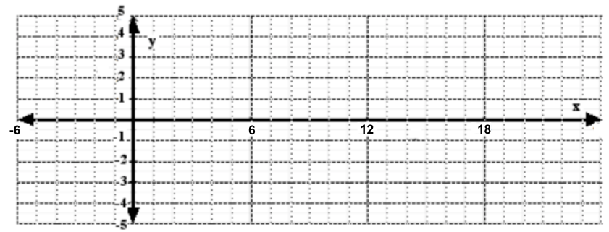

7.
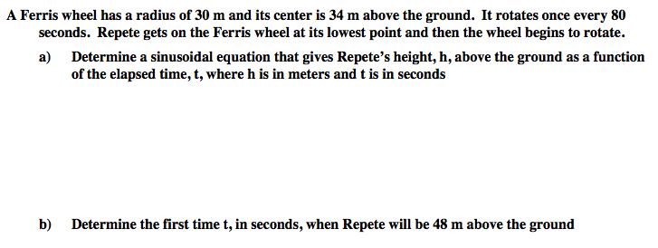

_______________________________________________________________________________
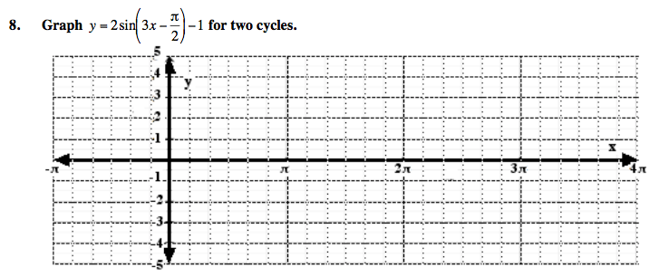

Learning Guide 14/15
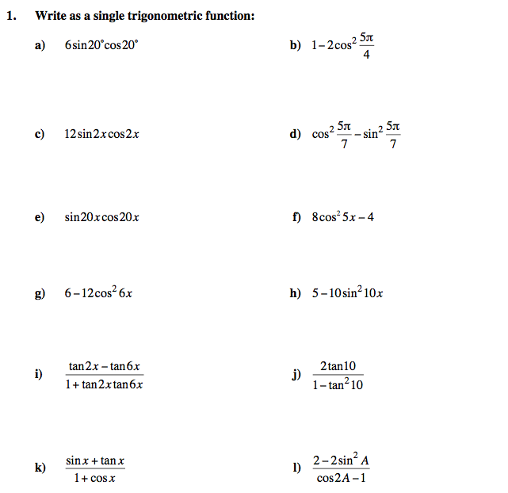

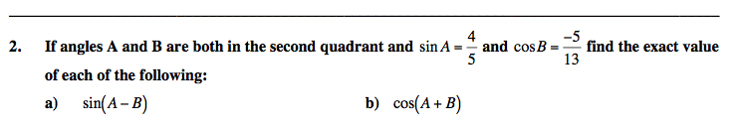

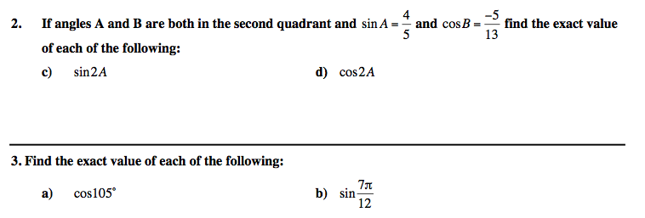

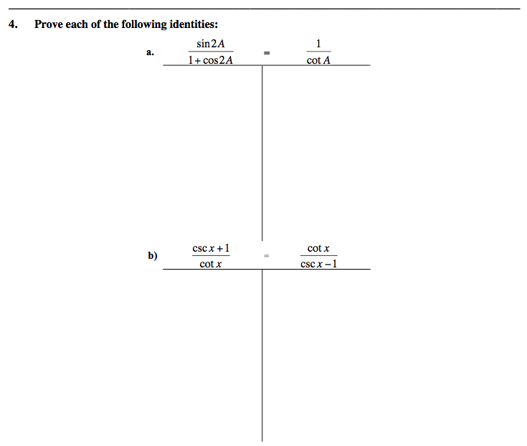

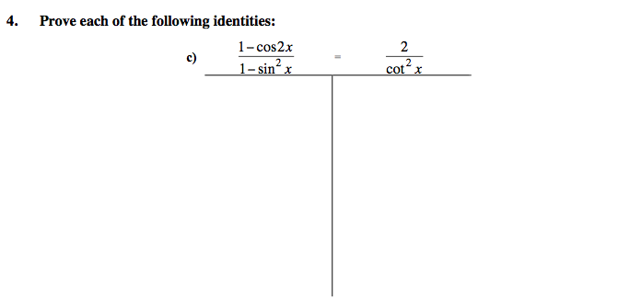

Learning Guide 16

1.
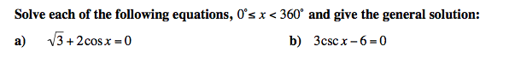

__________________________________________________________________________________
2.
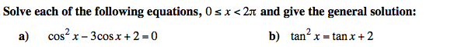

3.
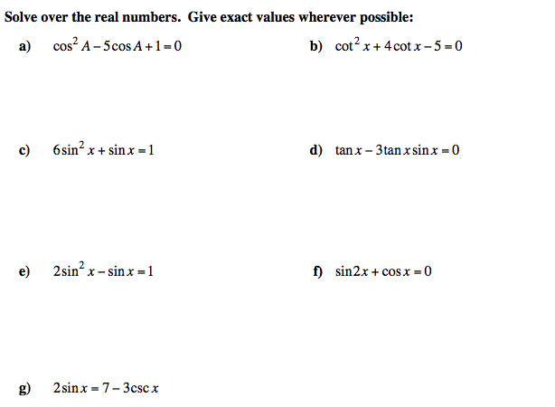

__________________________________________________________________________________
4.
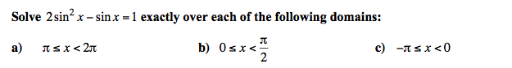

__________________________________________________________________________________
5.

