**PC12 LG 12A (Formative Assessment 2019)**

**Marking Teacher: _______________________ Name: __________________**

**Student #: __________________**

**1. Given the sinusoidal curve graphed below, write its equation in the form  and .**

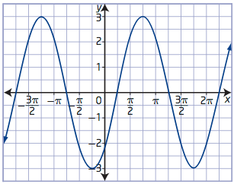

_________________________________________________________________________________________

**2. Given the function  answer the following questions:**

a) amplitude b) period

c) vertical displacement d) phase shift

e) domain f) range

_________________________________________________________________________________________

**3. Write an equation of the cosine function with amplitude 4.5, period 16π, phase shift to the left and vertical displacement of 18.**

**4. Determine the equation of the sinusoidal function with a maximum at (-4, 12) and the nearest minimum to the right at (12, -8). Write your answer as both a sine and as a cosine function.**

_________________________________________________________________________________________

**5. Graph each of the following functions:**

**a) , 0˚ < x < 180˚.**



**b)  for 2 cycles**



|  |  |  |  |  |  |  |
| --- | --- | --- | --- | --- | --- | --- |
| Directions: |  | **See me about this** |  | **Move on to next guide** |  | **Review and redo** |

**PC12 LG 12B (Formative Assessment)**

**Marking Teacher: _______________________ Name: __________________**

**Student #: __________________**

**1. Given the sinusoidal curve graphed below, write its equation in the form  and .**

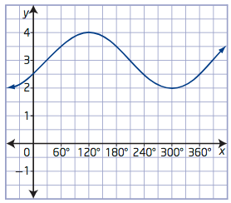

______________________________________________________________________________________

**2. Given the function answer the following questions:**

a) amplitude b) period

c) vertical displacement d) phase shift

e) domain f) range

_________________________________________________________________________________________

**3. Write an equation of the sine function with amplitude 8.5, period 4π, phase shift to the right and vertical displacement of -19.**

**4. Determine the equation of the sinusoidal function with a minimum at (5, -12) and the nearest maximum to the right at (11, -2). Write your answer as both a sine and as a cosine function.**

_________________________________________________________________________________________

**5. Graph each of the following functions:**

**a) , 360˚ < x < 540˚.**



**b)  for 2 cycles**



|  |  |  |  |  |  |  |
| --- | --- | --- | --- | --- | --- | --- |
| Directions: |  | **See me about this** |  | **Move on to next guide** |  | **Review and redo** |