**PC12 LG 1A (Formative Assessment 2019)**

**Marking Teacher: _______________________ Name: __________________**

**Student #: __________________**

**1. Describe in words how the graph of the following function can be found from the graph of :**



_________________________________________________________________________________________

**2. If (-2, 5) is a point on the graph of , find a point on the graph of .**

_________________________________________________________________________________________

**3. The graph of y = x3 is translated 5 units to the left and 4 units down to form the transformed function . Determine the equation of the function .**

**4. The domain of the function  is  and the range is . Find the domain and range of the function .**

_________________________________________________________________________________________

**5. Given the graph of  below, find the equation of the transformed function .**

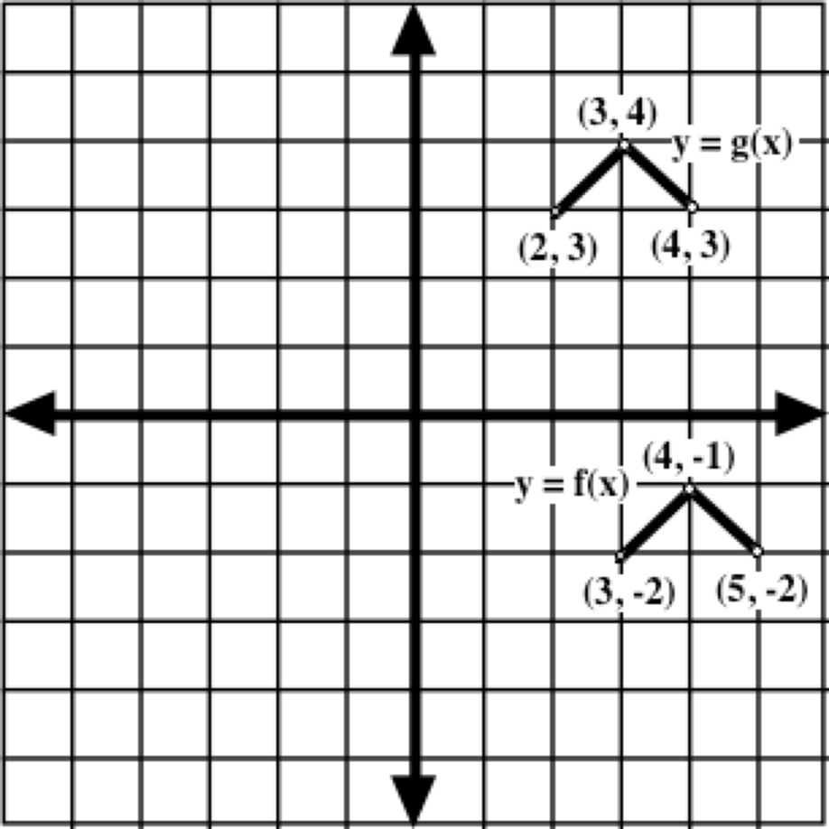

_________________________________________________________________________________________

**6. Given the graph of , sketch the graph of .**

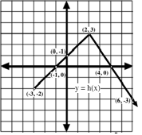

|  |  |  |  |  |  |  |
| --- | --- | --- | --- | --- | --- | --- |
| Directions: |  | **See me about this** |  | **Move on to next guide** |  | **Review and redo** |

**PC12 LG 1B (Formative Assessment)**

**Marking Teacher: _______________________ Name: __________________**

**Student #: __________________**

**1. Describe in words how the graph of the following function can be found from the graph of :**



_________________________________________________________________________________________

**2. If (4, -6) is a point on the graph of , find a point on the graph of .**

_________________________________________________________________________________________

**3. The graph of y = x2 is translated 3 units to the right and 5 units up to form the transformed function . Determine the equation of the function .**

**4. The domain of the function  is  and the range is . Find the domain and range of the function .**

_________________________________________________________________________________________

**5. Given the graph of  below, find the equation of the transformed function .**

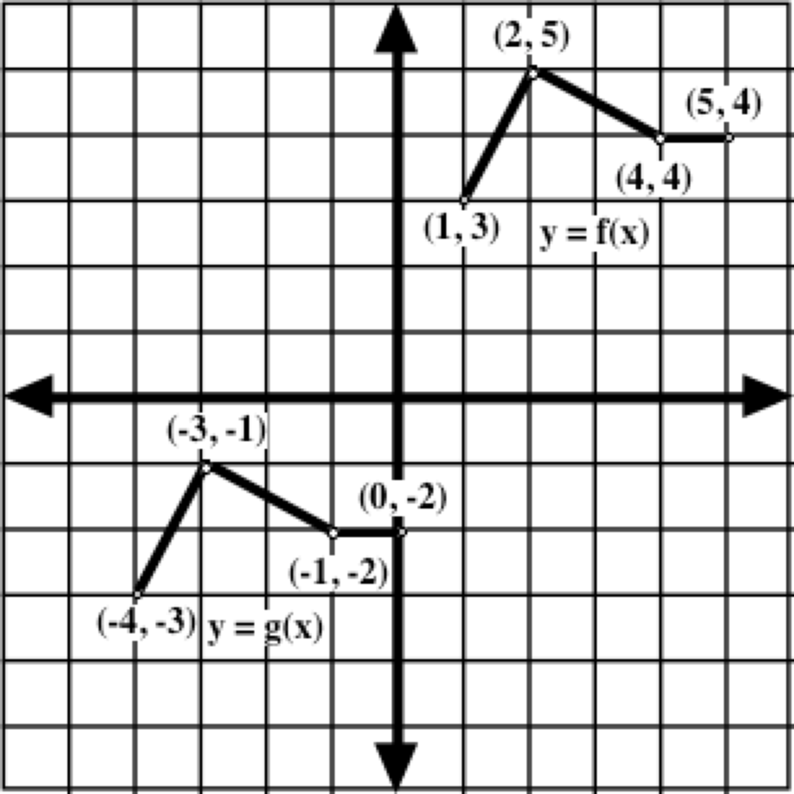

_________________________________________________________________________________________

**6. Given the graph of , sketch the graph of .**

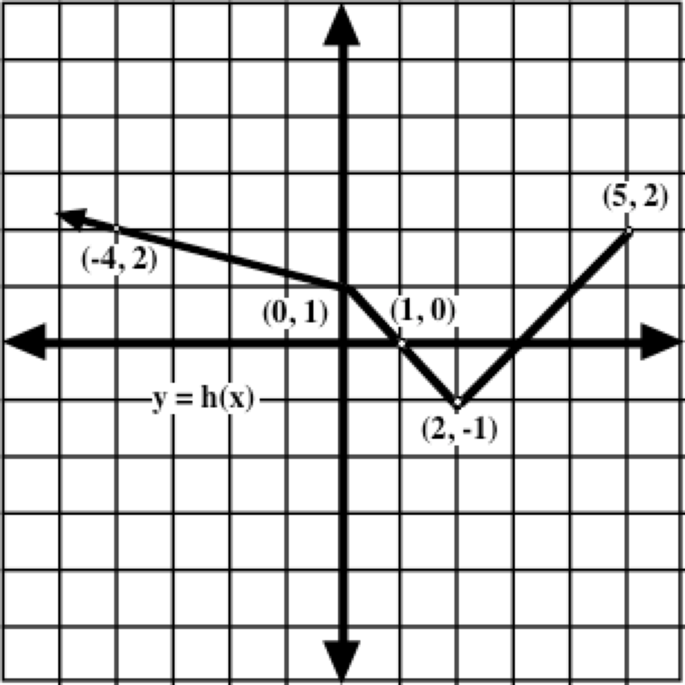

|  |  |  |  |  |  |  |
| --- | --- | --- | --- | --- | --- | --- |
| Directions: |  | **See me about this** |  | **Move on to next guide** |  | **Review and redo** |