**PC12 LG 3A (Formative Assessment 2019)**

**Marking Teacher: _______________________ Name: __________________**

**Student #: __________________**

**1. For the function**  **determine the interval(s) where the function is negative.**

_________________________________________________________________________________________

**2. Find the remainder when the polynomial**  **is divided by**  **.**

_________________________________________________________________________________________

**3. The zeros of a cubic function are 1 and -3 (*multiplicity 2*). Determine the equation of the function that has these zeros and passes through the point (-2, 9)**

**4. Determine the value of k so that**  **is a factor of** **.**

_________________________________________________________________________________________

**5.** **Use the graph of the given polynomial function to write its equation.**

|  |  |
| --- | --- |
|  |  |

_________________________________________________________________________________________

**6. For what value of *c* will the polynomial have the same remainder**

**when** **it is divided by**

_________________________________________________________________________________________

**7. Factor**  **fully. Use synthetic or long division.**

|  |  |  |  |  |  |  |
| --- | --- | --- | --- | --- | --- | --- |
| Directions: |  | **See me about this** |  | **Move on to next guide** |  | **Review and redo** |

**PC12 LG 3B (Formative Assessment)**

**Marking Teacher: _______________________ Name: __________________**

**Student #: __________________**

**1. For the function**  **determine the interval(s) where the function is positive.**

_________________________________________________________________________________________

**2. Find the remainder when the polynomial**  **is divided by** **.**

_________________________________________________________________________________________

**3. The zeros of a cubic function are 2 and -3 (*multiplicity 2*). Determine the equation of the function that has these zeros and passes through the point (-1, 24)**

**4. Determine the value of k so that**  **is a factor of** **.**

_________________________________________________________________________________________

**5. Use the graph of the given polynomial function to write its equation.**

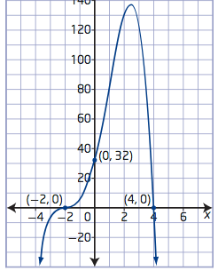

_________________________________________________________________________________________

**6. For what value of *c* will the polynomial have the same remainder**

**when** **it is divided by**

_________________________________________________________________________________________

**7. Factor fully. Use synthetic or long division.**

|  |  |  |  |  |  |  |
| --- | --- | --- | --- | --- | --- | --- |
| Directions: |  | **See me about this** |  | **Move on to next guide** |  | **Review and redo** |