PC12 LG 7A (Formative Assessment 2019)

Marking Teacher: _______________________ Name: __________________

Student #: __________________

1. Given $f\left(x\right)=4x^{2}+3x-1 and g\left(x\right)=6x+2$, perform the indicated operation.

$a) \left(f+g\right)\left(x\right)$ $b) \left(f-g\right)\left(x\right)$

_________________________________________________________________________________________

2. Given $f\left(x\right)=5x-6 and g\left(x\right)=x^{2}-5x+6$, perform the indicated operation.

$a) \left(g+f\right)\left(2\right)$ $b) \left(f-g\right)\left(-1\right)$

_________________________________________________________________________________________

3. Given $f\left(x\right)=6x^{2}-x-12 and g\left(x\right)=2x-3$, perform the indicated operation.

$a) \left(fg\right)\left(x\right)$ b)$\left(\frac{f}{g}\right)\left(x\right)$
4. Given $f\left(x\right)=9-x , g\left(x\right)=x^{2}+x+x, and h\left(x\right)=x-2$, perform the indicated operation.

$a) \left(f∘g\right)\left(x\right)$ $b) g\left(f(x)\right)$ $c) h\left(f(-6)\right)$

_________________________________________________________________________________________

5. For each given graph of f(x) and g(x), perform the indicated operation.
$a) \left(f+g\right)\left(1\right)$ $b) \left(g-f\right)\left(4\right)$
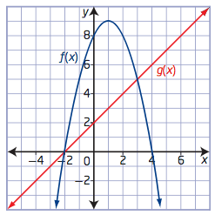

_________________________________________________________________________________________

6. For each graph of f(x) and g(x), determine the equation and state the domain & range for:
$a) \left(fg\right)\left(x\right)$ $b) \left(\frac{f}{g}\right)\left(x\right)$

Directions: |  | See me about this |  | Move on to next guide |  | Review and redo

PC12 LG 7B (Formative Assessment)

Marking Teacher: _______________________ Name: __________________

Student #: __________________

1. Given $f\left(x\right)=4x^{2}-3x-1 and g\left(x\right)=2x^{2}-3$, perform the indicated operation.

$a) \left(f+g\right)\left(x\right)$ $b) \left(g-f\right)\left(x\right)$

_________________________________________________________________________________________

2. Given $f\left(x\right)=x-1 and g\left(x\right)={4x}^{2}-x+6$, perform the indicated operation.

$a) \left(g+f\right)\left(-2\right)$ $b) \left(f-g\right)\left(4\right)$

_________________________________________________________________________________________

3. Given $f\left(x\right)=x^{2}+x-6 and g\left(x\right)=x-2$, perform the indicated operation.

$a) \left(fg\right)\left(x\right)$ b)$\left(\frac{f}{g}\right)\left(x\right)$

4. Given $f\left(x\right)=9-x , g\left(x\right)=x^{2}+x+x, and h\left(x\right)=x-2$, perform the indicated operation.

$a) \left(g∘f\right)\left(x\right)$ $b) f\left(f(x)\right)$ $c) h\left(g(-2)\right)$

_________________________________________________________________________________________

5. For each given graph of f(x) and g(x), perform the indicated operation.
$a) \left(f-g\right)\left(0\right)$ $b) \left(g+f\right)\left(2\right)$

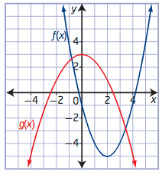

_________________________________________________________________________________________

6. For each graph of f(x) and g(x), determine the equation and state the domain & range for:
$a) \left(fg\right)\left(x\right)$ $b) \left(\frac{g}{f}\right)\left(x\right)$

Directions: |  | See me about this |  | Move on to next guide |  | Review and redo

