Writing Effective Introductions

(lesson adapted from: https://robinbneal.com/2014/01/12/no-dead-fish-teaching-students-to-write-effective-introductions/)

As a writer, you need to make a conscious effort to be warm and welcoming to

your reader. You want your reader to think, “Now THIS person is clever and warm and interesting. I want to read MORE of what he or she has to write.” To get this reaction, you need to create a **stylish, memorable, and effective introduction**.

*The three parts of any effective introduction*

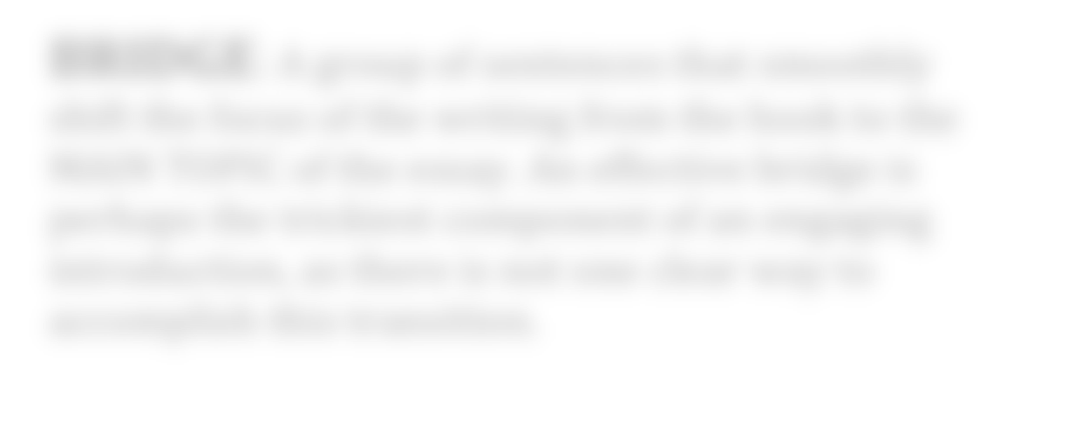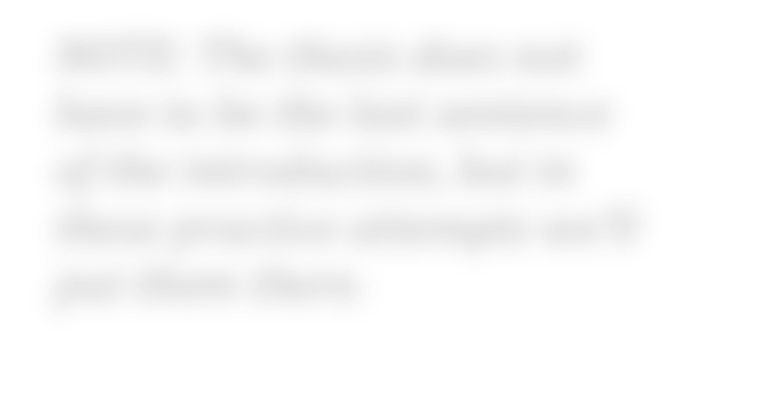

**HOOK**: an attention-­‐grabbing strategy that engages the reader (see separate

list). Effective hooks typically “begin somewhere else,” and, remember…

I

**BRIDGE**: A group of sentences that smoothly shift the focus of the writing from the hook to the MAIN TOPIC of the essay. An effective bridge is perhaps the trickiest component of an engaging introduction, as there is not one clear way to accomplish this transition.

*NOTE: The*  *thesis does not*

*have to be t* *he last sentence of the introd* *uction, but in these practice*  *attempts we’ll put them there* *.*

**THESIS**

Thesis statements contain a SUBJECT and OPINION. They need to be an **ARGUMENT** the essay will explain and prove.

EFFECTIVE HOOK TECHNIQUES:

**TAKE A RISK:** *No matter which technique you use, BE ORIGINAL and take a risk. Boring writing is predictable writing. Do something different…and a little weird.*

**Quotation or Statistic:** This method is also pretty lazy, unless your quotation or statistics are particularly engaging. I would encourage you to use another technique, but if you feel you have a great quote or stat, you might be able to pull this technique off.

**Personal story:** Readers respond to a personality, so share a short story about a moment in your life. You can accomplish quite a bit in a few short sentences if you give the reader an intimate, memorable “slice of life.”

**Memorable anecdote:** Again, tell a brief story but take it from someone else’s life. You do not need to use your story. Here’s an example:

*Before efficient extraction methods developed in the late 1880s, aluminum was exceedingly difficult to mine. As a result, pure aluminum was more valuable than gold. Napoleon gave banquets where the most honored guests were given aluminum utensils, while the others made do with gold.*

**Metaphor:** Creating your own metaphor or analogy is a wonderful way to add style to your writing. Beginning with your own comparison shows you understand so well that you can illustrate nuances through your own figurative language. Mastering the metaphor should be a goal of any writer.

**Unexpected Claim:** “There are more slaves in the world today than at any point in human history.” This statement seems to be false, but it is actually true. Beginning your essay with an unexpected claim can be very effective.

**Vivid Description**: Paint a word picture for your reader, focusing in on some object, place, or moment that connects to your general topic. If you can create memorable imagery, your readers will be more likely to engage with your essay.

**Humor**: If the situation calls for it, humor can be incredibly effective. Of course, humor is the most difficult tone to create in writing, but if you can pull it off…go for it.

Question:

**???Your Choice???:** This is not an exhaustive list. Try some other strategy not listed here. The most important thing is to be ORIGINAL and MEMORABLE.

**DIRECTIONS: Using three different colored highlighters or the highlighting tool in word, highlight the HOOK, the BRIDGE, and the THESIS in the following introductions. After highlighting these components, determine which HOOK strategies the authors employ.**

**“Down With Posters” Blog Post by Mr. Neal**

I despise glitter. It’s proudly tacky and sinisterly invasive. Once a bedazzled project crosses the threshold of my classroom, the insidious sparkles permanently lodge in every nook and cranny. Months later I look like Lady Gaga because I’ve accidentally scratched my head after brushing up against an errant drift of pixie dust. I ban the stuff. We’ve all seen effective, pedagogically sound projects carried out in this medium. Engaging visual aids, family trees in foreign languages, and movie posters for novels all make sense and can lead to critical thought. I argue, however, that this work becomes more effective and more sophisticated when teachers leverage web 2.0 tools to increase collaboration, develop authentic audiences, and extend the feedback loop.

**“Michael” by John Jeremiah Sullivan**

How do you talk about Michael Jackson except that you mention Prince Screws? Prince Screws was an Alabama cotton-plantation slave who became a tenant farmer after the Civil War, likely on his former master’s land. His son, Prince Screws, Jr., bought a small farm. And that man’s son, Prince Screws III, left home for Indiana, where he found work as a Pullman porter, part of the exodus of Southern blacks to the Northern industrial cities.

There came a disruption in the line. This last Prince Screws, the one who went north, would have no sons. He had two daughters, Kattie and Hattie, Kattie gave birth to ten children, the eighth boy, Michael—who would name his sons Prince, to honor his mother, whom he adored, and to signal a restoration. So the ridiculous moniker given by a white man to his black slave, the way you might name a dog, was bestowed by a black king upon his pale-skinned sons and heirs. We took the name for an affectation and mocked it.

***Secret Millionaire: May the Best Hobo Win***

More than 49 million Americans aren’t able to eat properly every day. America is one of the wealthiest countries in the world, yet our poverty rates are

frighteningly high. So what does the United States do? We make T.V. shows

about it. One is *Secret Millionaire*, where the upper class of our country go out into impoverished areas undercover as part of “a documentary about poverty and volunteering.” They go to different organizations each day and give a donation at the end of the week to those who they deem worthy. The media has designed

the series to be a heart-wrenching game show with the pitiful, helpless poor as the unknowing contestants. *Secret Millionaire* is a negative, exploitative addition to television because it does not portray the battle against poverty seriously, but rather for the audience’s entertainment.

***Secret Millionaire: The Sunny Side of Television***

Let’s face it. Between spending time on end on Facebook, buying expensive items we can barely afford and listening to crude songs, Americans as

a whole have been taken over with a serious case of narcissism. A place where

this narcissism is evident is in television, especially in America’s favorite type of shows, reality television. It usually involves a group of individuals getting drunk and swearing, all while being documented on camera for the viewers’ entertainment. But every once in a while, a reality show comes along that breaks the standards usually seen on television. *Secret Millionaire* is a reality show that follows affluent millionaires as they venture into poor communities across America and give their money to deserving people who are trying to make a

difference. Two of these millionaires are Gary and Diane Heavin, the co-founders of *Curves*, a multi-billion dollar weight loss corporation. The two left their

sprawling Texas ranch to live in one of the most run-down sections of Houston.

They volunteered at local organizations and, in the end, gave their money to some of the most deserving people. But while the premise of the show is supposed to improve people’s lives, does *Secret Millionaire* make a positive difference? In the age of crude and degrading reality television, *Secret Millionaire* stands out as a television program that makes a difference in people’s lives and has a positive impact on the viewers.

DIRECTIONS: Now, you will write your own practice introduction. You will need to decide on the HOOK strategy (or strategies) you will use. Your goal: to write an engaging, memorable, and polished introduction that begins with an effective **HOOK** (connected to the random topic), transitions smoothly to a controlled **BRIDGE** that narrows the focus, and end with your prescribed **THESIS**. Choose a thesis from the list below.

THESIS: **Violent video games do not create violent children. If anything, acting aggressively in a fantasy world makes real-­‐world violence less likely.**

THESIS: **Violent video games create violent children. Acting aggressively in a fantasy world increases the likelihood of real-­‐world violence.**

THESIS: **The legal drinking age should be lowered to**

**18 years of age. If an eighteen year old can vote, fight in wars, and legally care for a child, he should also be allowed to legally drink a beer.**

THESIS: **Professional athletes deserve the astronomical salaries they earn because they generate considerable money for the cities and organizations in which they play.**

THESIS: **Professional athletes do not deserve the astronomical salaries they earn because they do not contribute to society in meaningful ways.**

Your introduction:

Hook:

Bridge:

Thesis: