Thinking Critically about the Texts’ Purpose

Essential Question (to help guide your thinking): In what ways can symbolism reflect a group of people’s lived experiences?

What are some of the common examples of Indigenous symbolism? (discuss 4)
______________________________________________________________________________________________________________________________________________________________________________________________________________________________________________________________________________________________________________________________________________________________________________________________________________________________________________________________________________________________________________________________
What makes something an example of symbolism rather than just a random image?
______________________________________________________________________________________________________________________________________________________________________________________________________________________________________________________________________________________________________________________________________________________________________________________________________________________________________________________________________________________________________________________________
Thinking about your film and the people represented discuss one example of symbolism and why it might be important to that group of people.
______________________________________________________________________________________________________________________________________________________________________________________________________________________________________________________________________________________________________________________________________________________________________________________________________________________________________________________________________________________________________________________________
Why is it important to recognize that different symbols may have different meanings to the different groups of Indigenous people?
______________________________________________________________________________________________________________________________________________________________________________________________________________________________________________________________________________________________________________________________________________________________________________________________________________________________________________________________________________________________________________________________

Based on your learning so far about Indigenous Symbolism write a statement that summarizes how symbolism can reflect a group of people’s lived experiences?

Identify a key idea about each of the symbols listed below and briefly explain how it supports your statement about how symbolism can reflect a group of People’s lived experiences. Be sure to name the First Peoples you are discussing.
Medicine Wheel or Circle
Turtle
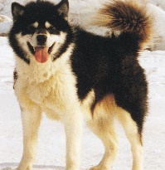
Inuit dog
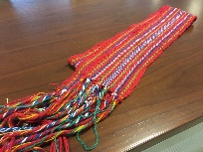
Métis Sash
Write a statement explaining how a deeper understanding of these symbols might affect your understanding of the associated Peoples lived experiences.

Choose one of the symbols present in the film/ doc you reviewed.
Review the section of the course that deals with sacred knowledge and protocols
Think about how the symbol is used in the film and what Indigenous group commonly uses that symbol. Review the history of the use of that symbol. Consider if there are any protocols surrounding the use of that symbol?
Respond critically to the following question in a well-developed multi-paragraph composition.
Communicate clearly and make an effective argument, using proper writing conventions and MLA guidelines for any reference to your research.
How does your chosen symbol reflect the associated First Peoples lived experiences?

