Water Tracker
Track all the water that you drink in a day and when you drank it.
You are also going to gauge your hydration level by the colour of your urine. Simply, take note of when you peed and the colour to provide an estimate of your hydration level.
Reflection: After your day of tracking water reflect on the amount of water you drank and your hydration levels. Do you drink other fluids? Were you hydrated throughout the day? Do you think you should drink more water? Why or why not?

Date:
Time  (Approximately) | Amount of water | Colour of urine  (Use the Chart as a guide) | 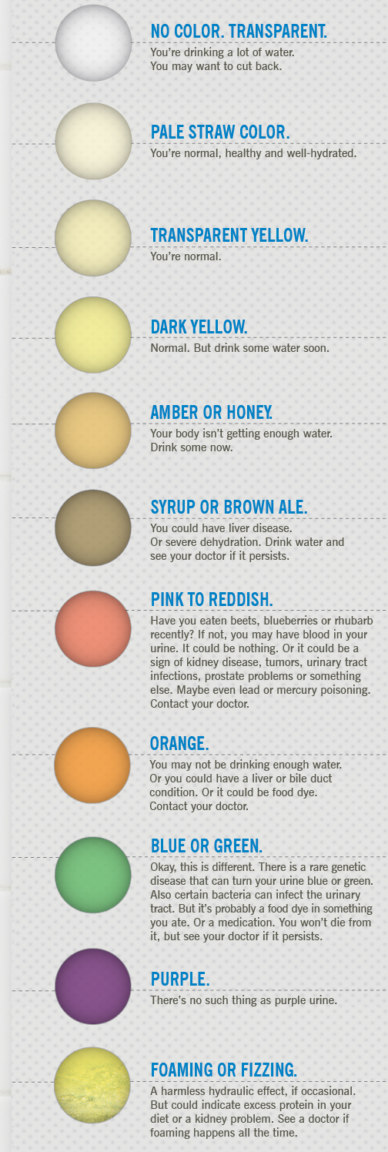

Reflection: After your day of tracking water reflect on the amount of water you drank and your hydration levels. Do you drink other fluids? Were you hydrated throughout the day? Do you think you should drink more water? Why or why not?

